**Pipes and Redirection Operation Assignment**

1. **Create a script named “myscript” in current directory to do the following.**

Vi command is used to create a script file named myscript with an extension .sh



1. **create a dir named “subd1” in current directory**

the mkdir command is used to create a directory named subd1

these statements are written in the shell.

subd1 directory got created .

1. **create a file named “dircontent” with contents of the current directory**

To create a file dircontent at same time with contents of the current directory we can use the redirection operator “>” .

So ls > ./dircontent is written in shell to create file dircontent

And the contents in it is displayed

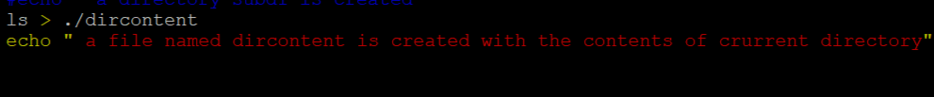

1. **display the contents of the file “dircontent”**

The cat command is used to display the contents of the file “dircontent”.

The contents in the file dircontent are shown below

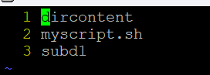

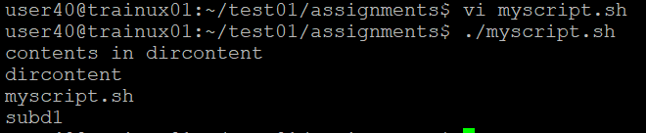

1. **display the contents of a non existing file named “unknownfile”**



Since the unknown file doesnot exist so there are no contents in them to get displayed.

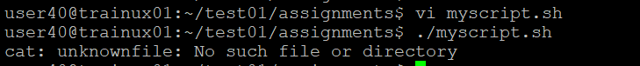

**2. Run the script and validate the output in following cases**

**a) Redirect only the stdout to an o/p file named stdout.txt**

To redirect only the stdout to an output file named stdout.txt, we use redirection operator “>” and “exec” command. Write “exec > stdout.txt” at top of the script, when we run the script this command writes only the output to the stdout.txt file without displaying in terminal.

**b) Redirect only the stderr to an o/p file named stderr.txt**

To redirect only the stderr to an output file stderr.txt, we use redirection operator “2>” and “exec” command. Write “exec 2> stderr.txt” at the top of the script, when we run the script this

command writes only the standard error to the stderr.txt file without displaying in terminal.

**c) Redirect both stdout and stderr to an o/p file named stdall.txt**

To redirect both stdout and stderr to an output file stdall.txt, we use redirection operator “&” and “exec” command. Write “exec > stdall.txt 2>&1” at the top of the script, when we run the script this command writes both the output and standard error to the stdall.txt file without displaying in terminal.

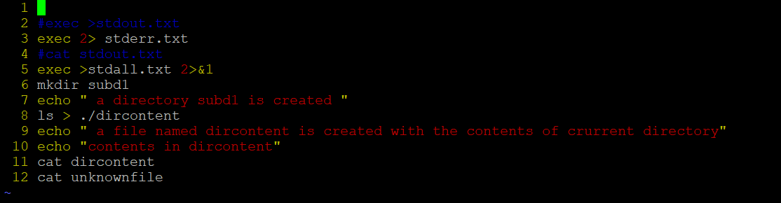

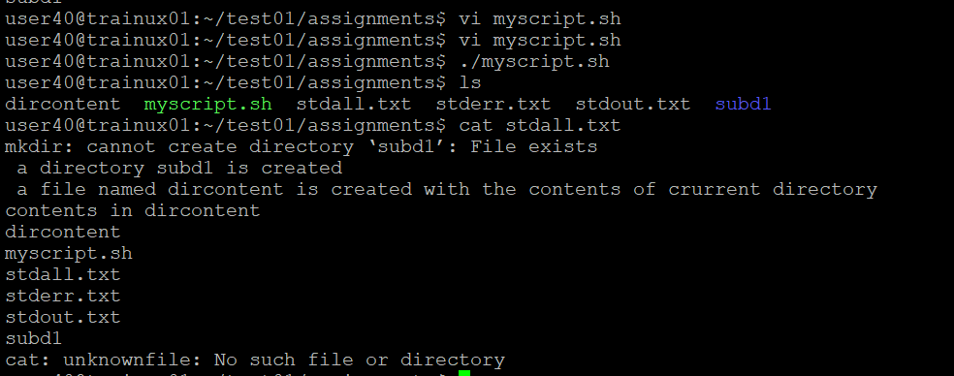

**d.)Display all o/p and error and also redirect both stdout and stderr to an o/p file named stdall.txt**

To both display and redirect the output and error we the “tee” command. Write exec > >(tee stdall.txt) 2>&1, when we run the script the output and error displayed and stored in stdall.txt file.

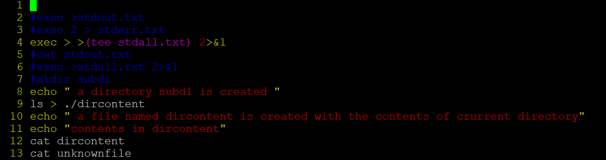

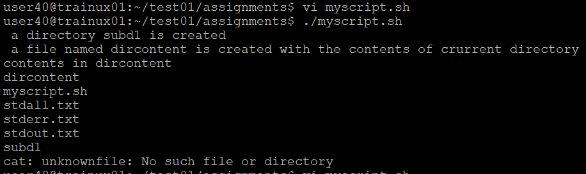

**3. Redirect the output of command below using pipe (|) to wc and get the output .ls -l?**

**A**. To redirect the output of command ls -l using pipe to wc, we write $ ls -l | wc and press enter to get output.

Output:

